FA2 Chapter 7 – COS & Inventory Set 1
Study Text, Course Notes & Kaplan
FAIZ: PLEASE PUT THE QUESTION NUMBERS AS FA2-Inv-S1-01-ST Q42
ST Q42
- Hanim made a mistake when she calculated the value of her closing inventory. As a result, the inventory is undervalued.

How is her profit for the year and net assets at the end of the year affected by this error?
Profit for the year Net assets
- Overstated Understated
- Overstated Overstated
- Understated Understated
- Understated Overstated
The correct answer is: C. Understated / Understated
Closing inventory is a credit in the statement of profit or loss so when it is undervalued it results in an understatement of profit. Closing inventory is also an asset in the statement of financial position, so undervaluing it also understates net assets.

ST Q43
- Ferhad runs a clothes shop selling replica football kits and valued all his inventory at 31 March 20X8 at its cost of $15,550.

Inventory includes 50 of last season's football kits which originally cost $30 and were on sale during the year for $50 each. However, now that new kits are out for the coming season, Ferhad knows he will have to reduce the old kits to half price in order to sell them.

Calculate the correct value for inventory at 31 March 20X8.
$ _________________

The correct answer is: $15,300
The kits from last season should be stated at the lower of the cost ($30) and the net realizable value ($25 which is half the original selling price of $50). Therefore, the inventory value is $15,550 – ($30 × 50) + ($25 × 50) = $15,300.

ST Q44
- The following records were kept for an inventory item in September.

September 1 100 units in inventory at $10 each
September 5 50 units bought at $10 each
September 12 60 units sold
September 20 20 units bought at $8 each
September 29 80 units sold

Using the FIFO method, what would be the value of inventory at 30 September?

- $300
- $260
- $340
- $220

The correct answer is: B. $260

30 units remain in inventory $
20 units @ $8 160
10 units @ $10 100
260

ST Q45
- Joe uses the continuous weighted average cost method of valuing inventories. During May 20X1, he recorded the following inventory details:

Opening balance 50 units valued at $4 each
4 May purchase of 50 units at $4.40 each
11 May issue of 80 units
19 May purchase of 60 units at $4.60 each
24 May issue of 50 units

What is the value of the inventory held at 31 May 20X1?

- $120.00
- $126.00
- $132.00
- $135.00

The correct answer is: D. $135.00

 | Units | Unit cost | Total | Average
 |  | $ | $ | $
Opening inventory | 50 | 4.00 | 200
4 May purchase | 50 | 4.40 | 220
 | 100 |  | 420 | 4.20
11 May issue | (80) | 4.20 | (336)
 | 20 |  | 84
19 May purchase | 60 | 4.60 | 276
 | 80 |  | 360 | 4.50
24 May issue | (50) | 4.50 | (225)
 | 30 |  | 135

ST Q46
- Christopher has recently commenced trading and is unsure how to value his inventory. He needs to decide whether to use First-In First-Out (FIFO), or continuous weighted average.

One of the raw materials he uses in his business is oil. The price of oil has consistently risen and is expected to continue to rise.

Which of the following statements is correct?

- Christopher's profit will be the same regardless of the method of inventory valuation adopted
- FIFO will lead to Christopher reporting a higher profit than if he uses continuous weighted average
- Continuous weighted average will lead to a higher reported profit than if he uses FIFO
- A more accurate profit will be reported if FIFO is used

The correct answer is: B. FIFO will lead to Christopher reporting a higher profit than if he uses continuous weighted average.
FIFO will lead to higher reported profit because his cost of sales will be based on the earliest (and therefore less expensive) purchases

CN Q44
- The entries required to correctly reflect inventory and cost of sales in the financial
statements for the first year of trading are:

- Debit Trading A/C – opening inventory
Credit Inventory (SOFP) – opening inventory
Debit Inventory (SOFP) – closing inventory
Credit Trading A/C – closing inventory
- Debit Inventory (SOFP) – opening inventory
Credit Trading A/C – opening inventory
Debit Trading A/C – closing inventory
Credit Inventory (SOFP) – closing inventory
- Debit Inventory (SOFP) – closing inventory
Credit Trading A/C – closing inventory
- Debit Inventory (SOFP) – closing inventory
Credit Payables – closing inventory

The correct answer is:
C. Debit Inventory (SOFP) – closing inventory
Credit Trading A/C – closing inventory

CN Q45
- An item of inventory could be sold for $100 after it has been modified at a cost of $21. The company incurs selling costs of 5% of selling price on each article sold. The cost is $45 per unit excluding carriage inwards of $2 and production overheads are $17 per unit.

Following the rules in IAS 2 at what valuation should this item be included in the inventory of the company?
- $47
- $64
- $74
- $85

The correct answer is: $64
NRV = 100 – 21 – (5% × 100) = $74
Cost = 45 + 2 + 17 = $64
Lower of cost and NRV = $64

CN Q46
- Danny Ltd had 200 units in inventory at 30 November 20X7 valued at $800. During December 20X7, it made the following purchases and sales.

02/12 Purchased 1,000 @ $5 each
05/12 Sold 700 @ $7.50 each
12/12 Purchased 800 @ $6.20 each
15/12 Purchased 300 @ $6.60 each
21/12 Sold 400 @ $8.00 each
28/12 Sold 500 @ $8.20 each

What is the value of closing inventory using FIFO?

- $3,540
- $4,460
- $3,220
- $2,740

The correct answer is: $4,460
$
FIFO 400 @ 6.20 2,480
300 @ 6.60 1,980
4,460

CN Q47
- Flint Ltd sells one line of inventory. At the year-end it has 200 units in inventory which originally cost $10 per unit and had incurred delivery costs of $120 in total. They expect these goods to sell for $13 per unit. Flint Ltd incurs selling costs amounting to 10% of the selling price on all its sales.

In the statement of financial position these items should be valued at:

- $2,000
- $2,080
- $2,120
- $2,600

The correct answer is: $2,120
$
200 @ $10 2,000
Delivery cost 120
2,120

Cost/ unit = $10.60

Net realisable value per unit = $13 × 90% = $11.70
⇒ valued at cost

CN Q48
- Luna makes the following purchases in the year:

Units $/unit Total ($)
(i) 21.01.X9 100 12.00 1,200
(ii) 30.04.X9 300 12.50 3,750
(iii) 31.07.X9 40 12.80 512
(iv) 01.09.X9 60 13.00 780
(v) 11.11.X9 80 13.50 1,080

At the year-end 200 units are in inventory but 8 are damaged and are only worth $10 per unit. These are identified as having been part of the 11.11.X9 delivery. Luna operates a FIFO system for valuing inventory.

The figure for inventory at 31.12.X9 is:

- $2,524
- $2,594
- $2,622
- $2,700

The correct answer is: A. $2,594
$
Inventory = 8 @ $10 = 80
72 @ $13.50 = 972
60 @ $13 = 780
40 @ $12.80 = 512
20 @ $12.50 = 250
200 2,594

Kaplan 141
- Fariz recently commenced trading. The materials Fariz uses in the business are subject to regular price rises. Fariz is unsure how to value inventory and is trying to decide whether to use 'first in, first out' (FIFO), or continuous weighted average.

Which of the following statements is correct?

- Fariz's profit will be unaffected by the method of inventory valuation
- FIFO will lead to the higher reported profit
- Continuous weighted average will lead to the higher reported profit
- The profit will be more accurate if FIFO is used

The correct answer is: B. FIFO will lead to the higher reported profit

Kaplan 142
- Yana are preparing the final accounts for a business. The cost of the items in closing inventory is $41,875. This includes some items which cost $1,960 and which were damaged in transit. Yana estimated that it will cost $360 to repair the items, and that the items could then be sold for $1,200.

What was the correct inventory valuation for inclusion in the final accounts?
$ {1:NUMERICAL:=40755}

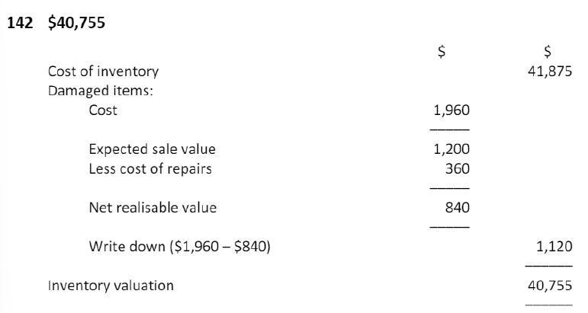

Kaplan 143
- Susanti uses the first in, first out method of inventory valuation. At 1 May 20X8 Susanti had 60 units in inventory at a total value of $1,320. The movements in inventory in May 20X8 were as follows:

Receipts
14 May 120 units at $22.20
26 May 150 units at $22.30

Sales
18 May 90 units
28 May 80 units

What was the value of Susanti's inventory at 31 May 20X8?
$ {1:NUMERICAL:=3567}

Closing inventory is 160 units. Using FIFO, 150 of these are all deemed to be part of the final delivery, and therefore they are valued at $22.30 per unit = $3,345. The remaining 10 units are deemed to be part of the previous delivery and are therefore valued at $22.20 per unit = $222.

The correct answer is: $3,567

Kaplan 144
- Manesh uses the periodic weighted average method of inventory valuation. At 1 August 20X6 Manesh had 60 units in inventory at a total value of $1,320. The inventory movements during August 20X6 were as follows:

Receipts
14 Aug 120 units at $22.50 per unit
26 Aug 150 units at $23.36 per unit

Sales
18 Aug 90 units
28 Aug 80 units

What was the value of Manesh's inventory at 31 August 20X6?
$ {1:NUMERICAL:=3648}

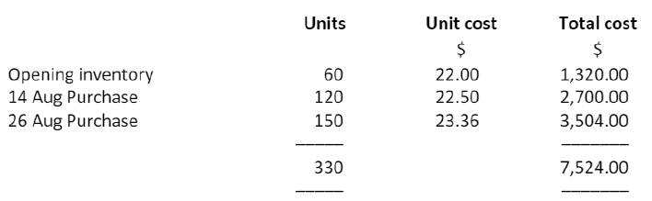

Kaplan 145
- Kunta Kinte the continuous weighted average cost method of inventory valuation. At 1 February 20X4 Kunta Kinte had 60 units in inventory at a total value of $1,320. The inventory movements during February 20X4 were as follows:

Receipts 14 Feb 180 units at $23.00 per unit
Sales 18 Feb 90 units at $30.00 per unit

What was the value of Kunta Kinte's inventory at 28 February 20X4?

- $3,300.00
- $3,390.00
- $3,412.50
- $3,450.00
The correct answer is: C. $3,412.50

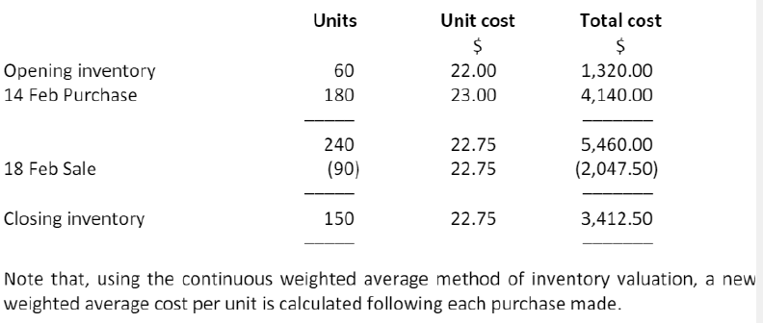

Kaplan 146
- Andrew uses the continuous weighted average cost method of inventory valuation. At 1 April 20X5 Andrew had 120 units in inventory at a unit cost of $22.00. The inventory movements during April 20X5 were as follows:

Receipts 15 Apr 360 units at $23.00 per unit
Sales 25 Apr 300 units at $32.00 per unit

What was Andrew's cost of sales for the month of April 20X5?
${1:NUMERICAL:=6825}

